AI Assisted Coding
B.Charan
2303A51623
Batch-08
Task 1: Zero-Shot Prompting – Leap Year Check
Scenario
Zero-shot prompting involves giving instructions without providing examples. Code:
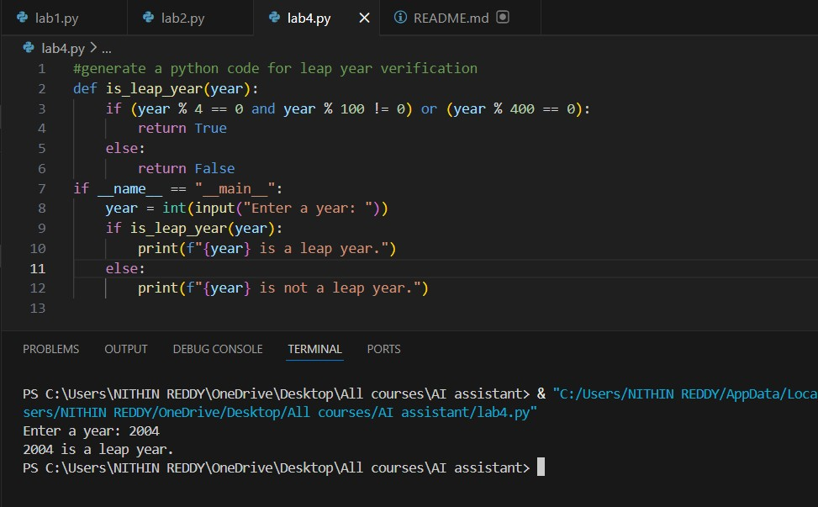

Task 2: One-Shot Prompting – Centimeters to Inches Conversion
Scenario
One-shot prompting guides AI using a single example.
Code:
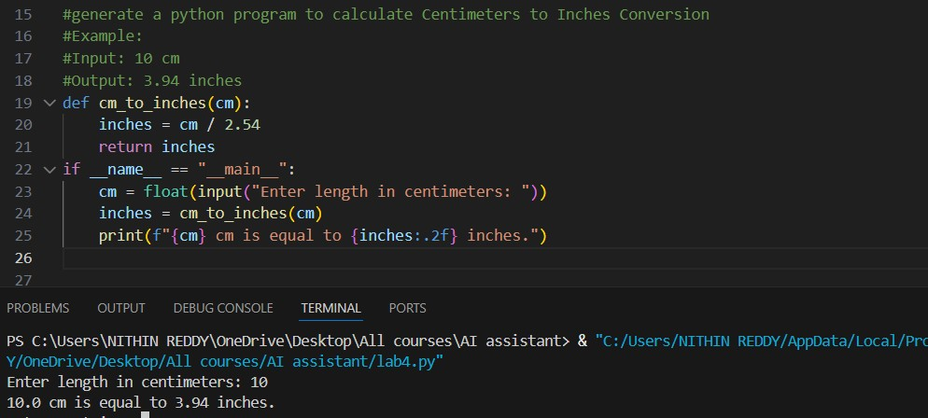
Task 3: Few-Shot Prompting – Name Formatting
Scenario
Few-shot prompting improves accuracy by providing multiple examples. Code:
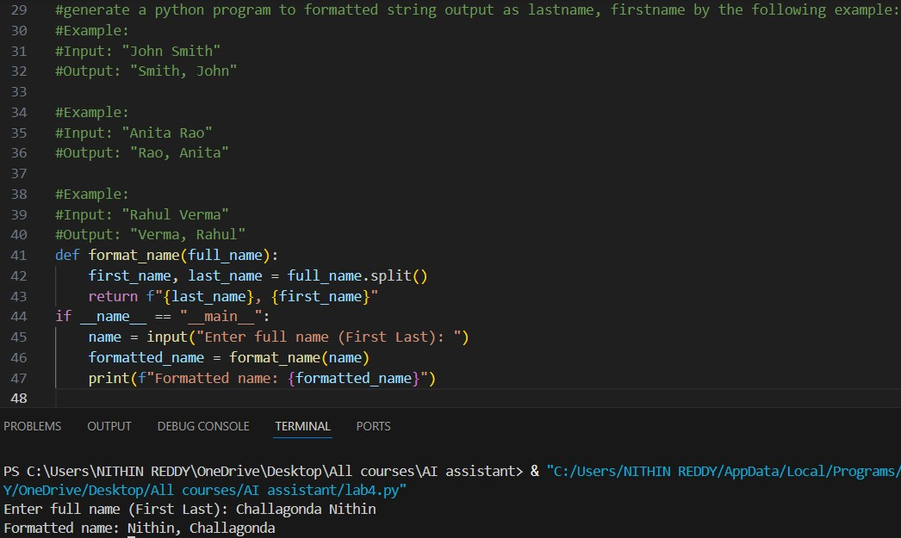
Task 4: Comparative Analysis – Zero-Shot vs Few-Shot
Scenario
Different prompt strategies may produce different code quality.
Code:
